**Name:** Walid Sultan Aly Ahmed Id: 984627

Assignment 1

**R-1.1**

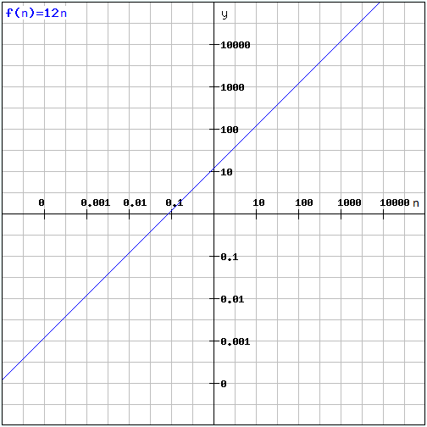 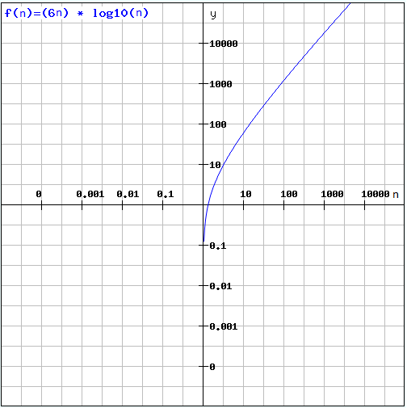

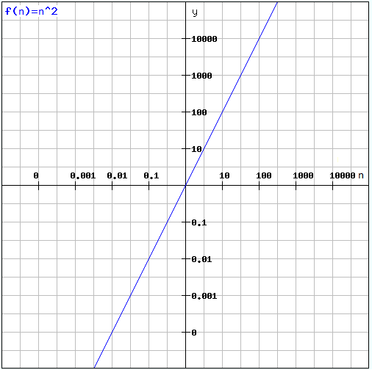 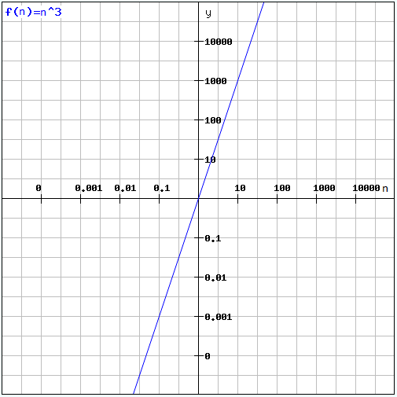

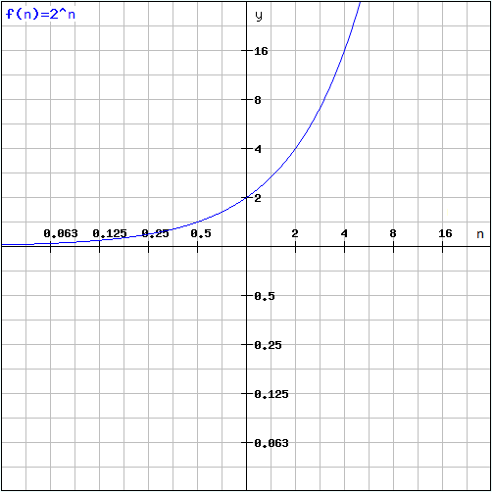

**R-1.2**

10*n* log *n <= n2*

10 log *n <= n*

*no* = 10

**R-1.6**

4n

2n

n3

n2 log n

4log n

2n log2 n

4n3/2

n log n

5n

n1/2

log log n

1/n

**R-1.10**

**Algorithm** Loop1(n)

s ← 0 1

**for** *i* ← 1 **to** *n* **do** n

*s* ← *s* + *i* n

**Algorithm** Loop1 runs in O(n) time

**R-1.14**

**Algorithm** Loop5(n)

s ← 0 1

**for** *i* ← 1 **to** *n*2 **do** n2

**for** *j* ← 1 **to** i **do** n2 (n2+1)/2

*s* ← *s* + *i* n2 (n2+1)/2

AlgorithmLoop5 runs in O(n4) time

**Proof**

Logb xa = a logb x

let Logb xa = y

by = xa

by/a = x

logb by/a = logb x

y/a = logb x

y = a logb x

**Assignment 2**

**R-2.1**

**Algorithm** insertBefore(p, e)

Create new node v

v.element 🡨 e

v.next 🡨 p {link v to its successor}

v.prev 🡨 p.prev {link v to its predecessor}

(p.prev).next 🡨 v {link p old predecessor to its new successor}

p.prev 🡨 v {link p to its predecessor}

return v

**Algorithm** insertFirst(e)

firstPosition 🡨 L.first() {get the position of the first element in the list}

firstNode 🡨 insertBefore(firstNode, e)

return firstNode

**Algorithm** insertLast (e)

Create new node v

lastPosition 🡨 L.last()

v.element 🡨 e

v.prev 🡨 lastPosition {link v to its predecessor}

lastPosition.next 🡨 v {link lastPosition to its new successor}

return v

**C-2.1**

**Algorithm** findMiddle(L)

{Input: L is a doubly linked list}

{output: middle node of L}

h 🡨 L.header 1

t 🡨 L.trailer 1

while h ➢  t do n/2

h 🡨 L.after(h) n/2

t 🡨 L.before(t) n/2

return h 1

The running time for findMiddle(L) is O(n)

**C-2.2**

**Algorithm** enqueue(o)

S1.push(o) 1

**Algorithm** dequeue()

If S2.Empty() then 1

While ➢ S1.isEmpty() do n

S2.push(S1.pop()) 2n

Return S2.pop() 1

The running time of enqueue is O(1)

The running time of dequeue is O(n)

**C-2.3**

**Algorithm** push(o)

Q1.enqueue(o) 1

**Algorithm** pop()

While Q1.size()>1 do n

Q2.enqueue(Q1.enqueue()) 2n

e 🡨 Q1.dequeue() 1

tmp 🡨 Q2 1

Q2 🡨 Q1 1

Q1🡨 tmp 1

Return e 1

The running time of enqueue is O(1)

The running time of dequeue is O(n)

**C-2-4**

**Algorithm** permuteNumbers(s)

{Input sequence s}

{output sequence containing permutations of s}

create new sequence permutedList

create new sequence permutedListInner

t 🡨 skipFirstElement(s) {copy all of the elements in s except the first one to t}

if s.Size()>1 then

permutedListInner 🡨 permuteNumbers (t)

else

permutedListInner.addLast(t)

for each permutation in permutedListInner

for i🡨0 to s.size()-1 do

singlePermutation 🡨 copy(permutation)

singlePermutation.addAtRank(i, s.first())

permutedList.add(singlePermutation)

return permutedList

**Algorithm** skipFirstElement (s)

{Input sequence s}

{copy all of the elements in s except the first one to t}

Create new sequence t

For i🡨1 to s.size()-1 do

t.addLast(s. elemAtRank(i))

return t

**C-2-5**

**Algorithm** size()

Return (N-f +t) mod N

**Algorithm** isEmpty()

return (f = t)

**Algorithm** insertFront(o)

If size() = N-1 then

Throw vectorFullException()

else

f 🡨 (f-1) mod N

V[f] 🡨 o

**Algorithm** deleteFront()

If isEmpty() then

Throw vectorEmptyException()

else

f 🡨 (f+1) mod N

V[f] 🡨 null

**Algorithm** insertLast(o)

If size() = N-1 then

Throw vectorFullException()

else

t 🡨 (t+1) mod N

V[t] 🡨 o

**Algorithm** deleteLast()

If isEmpty() then

Throw vectorEmptyException()

else

t 🡨 (t-1) mod N

V[t] 🡨 null

**Algorithm** elementAtRank(r)

If r<0 V r > size() then

Throw outOfIndexException()

Else

Pos 🡨 (N-f +r) mod N

Return V[pos]

**Assignment 3**

**R-2.7**

**Algorithm** root()

Return S.elemAtRank(1)

**Algorithm** parent(v)

If p(v) mod 2 > 0

Return S.elemAtRank( (p(v)-1) /2 )

Else

Return S.elemAtRank( P(v)/2 )

**Algorithm** leftChild(v)

Return S.elemAtRank( 2p(v))

**Algorithm** rightChild(v)

Return S.elemAtRank( 2p(v) + 1)

**Algorithm** isInternal(v)

Return ( (2 p(v)+ 1)< (S.size()-1) ∧ (leftChild(v) ➢  null V rightChild(v) ➢  null) )

**Algorithm** isExternal(v)

Return ➢  isInternal(v)

**Algorithm** isRoot(v)

Return v= root()

**R-2.8**

a)

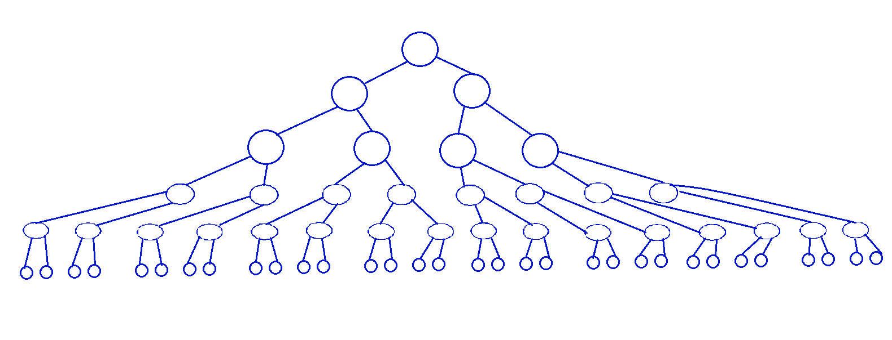

b) e= i+1

i >= h

e >= h+1

The minimum number of external nodes is h +1

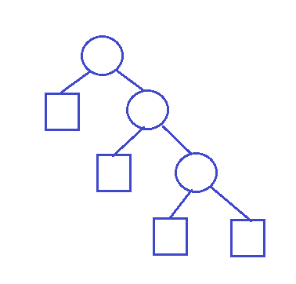

c)

I <= 2h – 1

I = e – 1

e<= 2h

The maximum number of external nodes for a binary tree is 2h

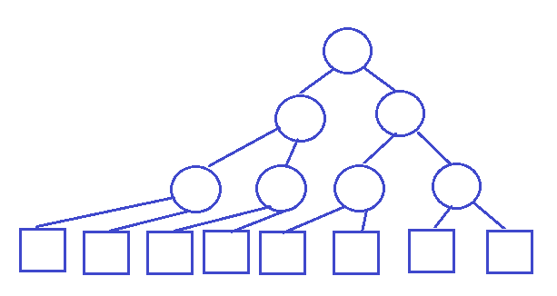

d) h <= I <= 2h – 1

h+1 <= e <= 2h

2h+1 <= n <= 2h+1 – 1

n >= 2h+1 ∧ n <= 2h+1 – 1

h <= (n-1)/2 ∧ h >= log(n+1) -1

log(n+1) -1 <= h <= (n-1)/2

e) log(n+1) -1 = (n-1)/2

log(n+1) = (n+1)/2

The above relation is true for:

n+1 =2 or n+1 = 4

n=1 and h=0

n=3 and h=1

**C-2.2**

Suppose we have two stacks S1 and S2. Enqueue just push the element to S1. Dequeue is implemented by doing pop on S2 if S2 is not empty. If S2 is empty then pop all the elements from S1 to S2 then pop the first element from S2.

If we set the weight for Enqueue to be 2, then we will have one extra credit when moving each element from S1 to S2. Thus the for n operations the running time is O(n). As a result, each operation runs in O(1) amortized time.

**C-2.7**

**Algorithm** shuffleDeck(s)

{Input s: sequence of cards to be shuffles}

shuffledSquence 🡨 Create new sequence Array Linked List

while ➢ s.isEmpty() do O(n) O(n)

randomElement 🡨 s.removeAtRank(randomInt(s.size())) O(n2) O(n)

shuffledSquence.addLast(randomElement) O(n) O(n)

return shuffledSquence

The running time Array based sequence is O(n2)

The running time Linked List based sequence is O(n)

**Assignment 4**

**R-2.8**

Running Time

22 15 26 44 10 3 9 13 29 25 10 {insertion of 10 items in unsorted sequence}

3 15 26 44 10 22 9 13 29 25 9 {comparisons are needed}

3 9 26 44 10 22 15 13 29 25 8

3 9 10 44 26 22 15 13 29 25 7

3 9 10 13 26 22 15 44 29 25 6

3 9 10 13 15 22 26 44 29 25 5

3 9 10 13 15 22 25 44 29 26 4

3 9 10 13 15 22 25 26 29 44 3

3 9 10 13 15 22 25 26 29 44 1

Total running time = 53

**R-2.9**

22 15 26 44 10 3 9 13 29 25 10

15 22 26 44 10 3 9 13 29 25 1

15 22 26 44 10 3 9 13 29 25 1

15 22 26 44 10 3 9 13 29 25 1

10 15 22 26 44 3 9 13 29 25 8 {4 swaps + 4 comparisons}

3 10 15 22 26 44 9 13 29 25 10

3 9 10 15 22 26 44 13 29 25 10

3 9 10 13 15 22 26 44 29 25 2

3 9 10 13 15 22 26 29 44 25 6

3 9 10 13 15 22 25 26 29 44 0

Total running time = 49

**R-2.10**

4 3 2 1 4 {4 insertions}

3 4 2 1 2 {1 comparison + 1 swap}

2 3 4 1 4 {2 comparisons + 2 swaps}

1 2 3 4 6

Total running time = 16

Any array sorted in descending order should have Ω(n2) running time

**R-2.13**

Since the items in the vector are sorted, then the key of any item will be greater than or equal to its parent. As a consequence, tree T is a heap.

**R-2-18**

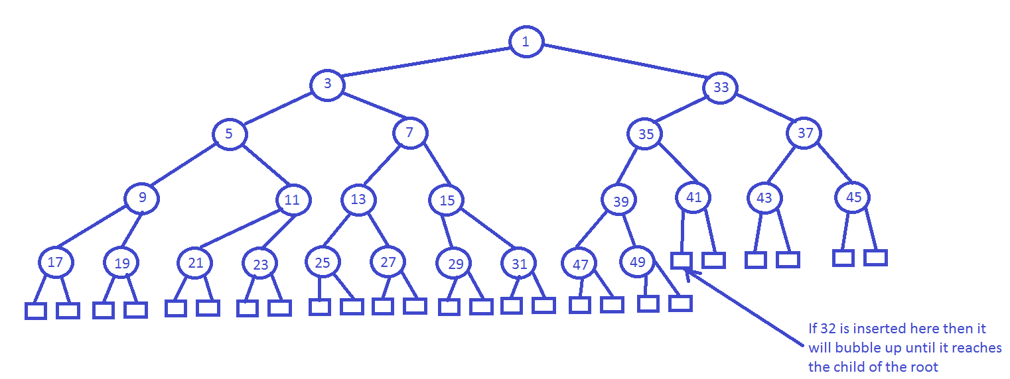

**C-2.32**

**Algorithm** reportSmallerKeys(H, x)

s 🡨 create new sequence

i 🡨 1

while i <= H.size() ∧ H[i] <= x do

s.insertLast(H[i])

i 🡨 i +1

return s

**Assignment 5**

R-4.2

**Algorithm** mergeSort(S, C)

Input sequence S with n elements, comparator C

Output sequence S sorted according to C

if S.size() > 1 then

(S1, S2) 🡨 partition(S, n/2)

mergeSort(S1, C)

mergeSort(S2, C)

S 🡨 merge(S1, S2, C)

**Algorithm** merge(A, B, C)

Input sequences A and B with n/2 elements each, comparator C

Output sorted sequence of A and B

S 🡨 empty sequence

while ➢A.isEmpty() ∧ ➢B.isEmpty() do

if C.isLessThan( B.first().element(), A.first().element() ) then

S.insertLast(B.remove(B.first()))

else

S.insertLast(A.remove(A.first()))

while ➢A.isEmpty() do

S.insertLast(A.remove(A.first()))

While ➢B.isEmpty() do

S.insertLast(B.remove(B.first()))

return S

**R-4.5**

**Algorithm** specialMerge(A, B, C)

Input sequences A and B with n/2 elements each, comparator C

Output sorted sequence of A and B

S 🡨 empty sequence

while ➢A.isEmpty() ∧ ➢B.isEmpty() do

if C.isLessThan( B.first().element(), A.first().element() ) then

S.insertLast(B.remove(B.first()))

Else if C.isEqual(B.first().element(), A.first().element()) then

S.insertLast(B.remove(B.first())

A.remove(A.first())

else

S.insertLast(A.remove(A.first()))

while ➢A.isEmpty() do

S.insertLast(A.remove(A.first()))

While ➢B.isEmpty() do

S.insertLast(B.remove(B.first()))

return removeRepeated(s)

**Algorithm** removeRepeated(s)

For i🡨0 to s.size()-2 do

If s.elemAtRank(i) = s.elemAtRank(i+1) then

s.removeAtRank(i)

i 🡨 i-1

return s

**R-4.9**

Since the list is already sorted then best running time will be the case, which is O(n log(n))

**C-4.10**

1. Sort the sequence S using Heap-Sort. The running time should be O(n log n)
2. Initialize two variables currentCount and maxCount
3. Iterate on the sorted sequence, and increment the currentCount until the ID changes, then compare currentCount with maxCount. If currentCount is greater than set maxCount as currentCount. The running time for the operation is O(n)

The total running time is O(n log n)